DAYANANDA SAGAR UNIVERSITY
Devarakaggalahalli, Harohalli Kanakapura Road, Dt, Ramanagara, Karnataka 562112



Bachelor of Technology
in
COMPUTER SCIENCE AND ENGINEERING
(Artificial Intelligence and Machine Learning)



Project
DISASTER LENS

By
VINAY K Y
USN-ENG23AM0207
GR AYUSH
USN-ENG23AM0126
NOMAN
USN -ENG23AM0125

Under the supervision of
Dr. Sugandha Saxena
Assistant Professor, CSE(AIML), SOE, DSU

TABLE OF CONTENTS

Page

LIST OF ABBREVIATIONS ................................................................................. 3
LIST OF FIGURES ……….................................................................................... 4
ABSTRACT ........................................................................................................... 5

CHAPTER 1 INTRODUCTION……….............................................................. 6
CHAPTER 2 PROBLEM DEFINITION ………................................................. 7
CHAPTER 3 LITERATURE REVIEW................................................................. 8
CHAPTER 4 METHODOLOGY........................................................................... 11
CHAPTER 5 WORK FLOW.................................................................................. 14
CHAPTER 6 RESULTS AND ANALYSIS …..................................................... 19
CHAPTER 7 CONCLUSION AND FUTURE WORK …………………………. 20
CHAPTER 8 PAPER PUBLICATION ….............................................................. 22
REFERENCES……………………………………………………………………. 23

LIST OF ABBREVIATIONS
AI | Artificial Intelligence
DL | Deep Learning
NLP | Natural Language Processing
CV | Computer Vision
LLaVA | (Implied Model Name)
ERs | Emergency Responders
GIS | Geographic Information Systems
RS | Remote Sensing
SVM | Support Vector Machines
NB | Naive Bayes
RF | Random Forest
CNN | Convolutional Neural Networks
SMTP | Simple Mail Transfer Protocol

LIST OF FIGURES

Fig. No. | Description of the figure | Page No.
1 | Console output confirming application launch and successful database initialization. | 15
2 | Tweet fetching stage with live data (mock data unchecked) showing raw, unclassified tweets. | 15
3 | Successful fetching and display of mock disaster tweets ready for analysis | 16
4 | Proof co Proof for the alert delivery mechanism | 16
5 | Real Time fetching of tweets | 16
6 | The Review and Edit stage, showing the extracted disaster categories (e.g., Flood, Fire, Traffic) and locations before final dispatch. | 17
7 | Console output confirming the alert rate limiting mechanism is active and skipping recent duplicate alerts. | 18
8 | The Disaster Alert System Dashboard, showing subscription management and the two-step alert generation workflow | 18

ABSTRACT

This project meets the most urgent needs in current crisis management, as the volume and unstructured character of data tend to overwhelm emergency response activities. Classic command-and-control strategies are no longer sufficient with the enormous volumes of high-velocity data produced by social media, sensors, and satellites during emergencies. The primary aim of this project is to deploy an integrated AI-based system to improve situational awareness, enhance coordination, and reduce the time and expense of processing critical information.

The technological underpinning of this effort is leveraging Artificial Intelligence (AI), Machine Learning (ML), and Deep Learning (DL) as force multipliers for data-driven analysis in time-sensitive environments. It will execute primary functionalities in each of the four phases of disaster management (mitigation, preparedness, response, and recovery) based mainly on ML methods such as classification and prediction on multi-source information. Most importantly, the project incorporates an AI-driven algorithm for effective extraction of structured data from unstructured text formats, i.e., PDFs, which make up more than 80% of data stores. The algorithm employs generative models, e.g., the GPT architecture, for semantic analysis to beat traditional, template-based extraction approaches. Successful deployment of such an AI-based solution is proven to cut document processing time by 26.7, attesting to its economic and operational effectiveness for adoption by researchers, scientific libraries, and emergency management agencies.

Key Areas of Focus: AI and ML in Crisis Response; Extraction of Unstructured Data; Interoperability; Economic Efficiency

CHAPTER 1
INTRODUCTION
In today's interconnected world, having real-time situational awareness is essential for effective disaster response and public safety. Traditional ways of monitoring disasters depend on official channels, which can fall behind actual events. The Real-Time Disaster Alert System fills this gap by using the quick, detailed reporting power of social media to deliver fast, localized emergency notifications.

The project sets up a strong, automated system that starts by gathering recent public reports (tweets) of disasters and emergencies. This raw data undergoes local AI analysis with Ollama. The Llama3 model uses Natural Language Processing (NLP) to pull out the exact event location and disaster type (such as "Flood," "Fire," or "Traffic") from the text. Meanwhile, the multimodal LLaVA model uses Computer Vision (CV) analysis on any images attached to verify known landmarks.

All processed information is saved in a relational database (tweets.db) for historical tracking. Importantly, the system also manages user subscriptions in a separate database (subscriptions.db), letting individuals sign up for alerts for specific geographic areas. A key feature of the system is its smart alerting logic, which groups multiple related reports, standardizes location names (for example, changing "Bangalore" to "bengaluru"), and uses a 6-hour log to avoid sending duplicate notifications for the same ongoing event. This refined information is then sent out as a single email alert to all relevant subscribers. The whole process—from managing subscriptions to reviewing final alerts—is handled through an easy-to-use Streamlit dashboard.

CHAPTER 2
PROBLEM DEFINITION

Traditional methods for disaster and emergency monitoring often suffer from significant latency and poor specificity, hindering rapid response efforts. Official reporting channels can be slow to confirm incidents, leaving communities in the dark during critical initial hours. Moreover, existing systems frequently fail to aggregate and contextualize the sheer volume of unstructured, raw data generated during an emergency.

Specifically, the challenges addressed by this project include:

1. Data Overload and Extraction Difficulty: Social media platforms are rich with real-time reports, but raw tweets are unstructured and contain noise. Identifying the exact location and nature of an emergency requires sophisticated, real-time Natural Language Processing (NLP) and, increasingly, Computer Vision (CV) to verify visual evidence like landmarks.
2. Alert Fatigue and Duplication: Multiple users often report the same incident, leading to an overwhelming number of redundant alerts for subscribers. There is a critical need for an intelligent system to group related reports, normalize location data (e.g., "Bangalore" and "bengaluru"), and implement time-based de-duplication to send a single, consolidated alert per unique event.
3. Lack of Targeted Notifications: Users need to receive alerts only for locations they care about. A robust subscription management system is required to handle sign-ups, removals, and efficient matching of localized events to the correct, targeted subscriber list.

The absence of an integrated, intelligent, and de-duplicated system results in delayed aid, misallocated resources, and diminished public trust in real-time information.
CHAPTER 3
LITERATURE REVIEW

The rising global expansion and severity of disasters have increased the complexity of crisis management, traditionally based on four interdependent phases: mitigation, preparedness, response, and recovery [3]. The literature firmly sets forth that Artificial Intelligence (AI), Machine Learning (ML), and Deep Learning (DL) technologies constitute indispensable force multipliers to safeguard human life and property by offering key, real-time processing capabilities of data during these phenomena [2], [4].

A. AI Applications in Phases of Disaster and Approach
Nunavath and Goodwin (2019) conducted a systematic review of literature illustrating AI's ubiquitous and significant presence throughout the entire disaster management process, observing that the majority of applications are based on ML and DL approaches for classification and prediction tasks [2].

Core Functions: The uses vary from storm movement prediction and forecasting hazard areas to social media posts classification regarding a disaster and evacuation route planning safest [2]. Abid et al. (2021) emphasize that the Response stage, being the most time-sensitive and public-facing, is given the broadest rollout of AI techniques with an aim for rapid and well-informed decision-making [3].

Shared Methodologies: The literature suggests a number of shared AI, ML, and DL methodologies that have been effectively utilized in natural and man-made disasters. These are Support Vector Machines (SVM), Naïve Bayes (NB), Random Forest (RF), Convolutional Neural Networks (CNN), and Natural Language Processing (NLP) [2]. Sun, Bocchini, and Davison (2022) also describe that most of the AI applications are focused on the disaster response stage, utilizing data-driven approaches to enhance situation awareness [2.3].

Socio-Technical Transformation: Turoff et al. (2009) explained the limitations of the conventional dependency on "command-and-control" practices [5]. This model has been replaced by another model in which the public is an active partner in information sharing, mainly using social media, according to Hiltz, Diaz, and Mark (2011) [1]. This transformation compels emergency managers to regard the public as a key collaborator [6]. Therefore, as discovered by Sutton, Palen, and Shklovski (2008), there is a need for systems that are capable of aggregating and verifying these spontaneous social media contributions, commonly known as "back-channel" reports [7].

B. Unstructured Data Extraction and Processing
The reliance on technology in disaster management has introduced the problem of dealing with enormous quantities of unstructured text information, which Moskalev, Gazizov, and Korobko (2025) estimate covers more than 80% of scientific and business data, often holding its place in such forms as PDF [4].

Legacy System Shortcomings: Moskalev, Gazizov, and Korobko (2025) note that traditional extraction tools like basic regular expression (regex) pattern matching are not enough for variable format documents since they necessitate a lot of manual template adjustment and are inflexible [4].

AI Solution: Moskalev, Gazizov, and Korobko (2025) suggest that AI-powered algorithms present a feasible solution through semantic analysis and context-based pattern recognition, thus doing away with the need for static information locations within the document [4]. Additionally, research on real-time social media monitoring during catastrophes points out that deep learning algorithms are robust to extract high-quality information from the vast quantities of unstructured user-generated content available on online sources [3.4].

Generative Models: Moskalev, Gazizov, and Korobko (2025) point to the strength of Generative AI, in particular GPT-based models, as a very robust solution. The models are capable of rewriting intricate, plain-text inputs into a structured JSON array that is ready for real-time database ingestion [4]. The approach has been experimentally proven to lower document processing time by several orders of magnitude in similar application scenarios [4].

C. Interoperability and Alert Fatigue
Hiltz, Diaz, and Mark (2011) recognize that a key challenge to multi-organizational crisis response is acquiring technical and social interoperability among all the involved agencies [1]. This is essential for coordination and collaboration across heterogeneous data models and systems [4.3].

Alert Fatigue: Beyond interoperability issues, Abid et al. (2021) add that the uncontrolled number of reports flowing in from citizens and sensors can lead to excessive alert fatigue for both responders and users [3]. In response to this, proper event grouping and de-duplication are now critical elements of current alert system design [3]. The warning fatigue literature further discusses this condition, observing that antecedents such as message content, relevancy, and frequency of alerts may create symptoms such as mental fatigue and, in turn, behaviors such as disengagement from emergency alert systems [4.2].
CHAPTER 4
METHODOLOGY

The methodology for the Real-Time Disaster Alert System is an engineering-focused, multi-stage development process centered on data acquisition, intelligent processing, structured storage, and event-driven notification. The approach combines web scraping with state-of-the-art local AI models for automated data analysis and is implemented through a Python-based software architecture.

1. Data Collection and Selection (Existing Data)
The primary method for data collection involved using existing data to simulate a live event environment and validate the core logic before deploying live API interaction:
Data Source Selection: The system is designed to acquire real-time textual and image-based reports from a social media API (Twitter/X, implied by twitter_search.py). This platform was chosen due to its high volume of immediate, user-generated content, which is crucial for early disaster warnings.

Case Study Material Selection (Mock Data): To facilitate development and testing, a small corpus of pre-analyzed mock data was created in a JSON format (moc_tweets.json).
Textual Materials: The mock data was structured to represent real-world scenarios, including tweets describing various disaster types (e.g., "Flood," "Fire," "Traffic") across different geographic locations (e.g., Bengaluru, Mumbai).
Selection Criteria: The materials were selected to test specific system functionalities: Location Normalization (e.g., using both "Bangalore" and "bengaluru" to ensure consolidation) and Disaster Grouping (e.g., having multiple reports of the same "Flood" event).
Live Data Collection (As-Implemented): The live system is designed to query the social media API using keywords such as 'disaster,' 'emergency,' 'flooding,' and 'fire,' specifically targeting events within India, while excluding retweets for originality. Data expansions were requested to include media key and URL fields necessary for image analysis.

2. Data Preparation and Intelligent Analysis
Before storage and alerting, the collected data underwent a rigorous preparation and enrichment process utilizing local, open-source AI models:
Cleaning and Standardization: The raw tweet text was fed directly into the analysis pipeline.
Feature Extraction (NLP): For each tweet, the raw text was passed to an instance of Ollama running Llama3. A strict system prompt was used to instruct the model to act as an expert information extractor and return the results only in a specific JSON format, identifying the primary location and the disaster type. This automated structuring of unstructured text was critical for subsequent database querying and alert grouping.

Visual Verification (CV): If a tweet contained an image URL, the image was downloaded and passed to Ollama running LLaVA. The model was prompted to identify any specific landmarks, famous buildings, or well-known locations. This step provided an additional layer of data enrichment and potential location verification before alert dispatch.
Data Preservation: All original and extracted data points (author ID, timestamp, text, extracted location, disaster type, image URL, and detected landmark) were saved to the raw_tweets table in the tweets.db database.

3. Alerting Logic and Database Management
The core alerting function relies on two sets of database interactions and a multi-step filtering process, ensuring targeted and relevant notifications:

Location Normalization: Extracted location data was passed through an internal mapping dictionary (e.g., "Bangalore" → "bengaluru") to ensure consistent geographic grouping, regardless of common spelling variations.
Event Grouping: The normalized tweets were grouped into unique events defined by the combination of (Normalized Location, Disaster Type).
De-duplication Check: For each unique event group, the sent_alerts table in subscriptions.db was checked to see if an alert for the same location and disaster type had been sent within the last 6 hours. Events failing this check were skipped to prevent alert fatigue.
Subscriber Retrieval: For every validated, new event, the subscriptions table was queried to retrieve all corresponding email addresses subscribed to that specific normalized location.
Notification Dispatch: Consolidated email messages were constructed, listing all supporting tweets for the event. The final alerts were dispatched to the retrieved subscribers using a standard SMTP protocol via the mail_alert.py module. The successful dispatch was immediately logged to the sent_alerts table to enforce the de-duplication window.

4. Implementation and User Interface
The methodology was implemented using Python and encapsulated within a Streamlit web application (app.py), which served as the central control panel.

Subscription Management: Subscriptions were managed directly through a sidebar interface, which executed add_subscription and remove_subscription functions, immediately applying changes to subscriptions.db.
Manual Review and Editing: A critical step involved displaying the processed data in an interactive st.data_editor. This allowed the human operator to review the AI-extracted location and disaster type and make manual corrections before the final Group and Send Alerts action was executed.
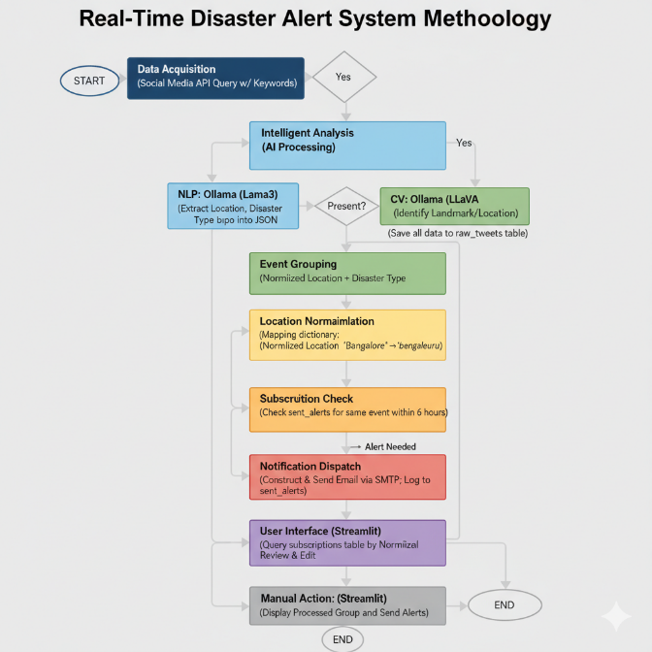
CHAPTER 5
WORKFLOW
The Disaster Alert System is intended to be operated locally, based on Python, Streamlit, and the local Ollama service. The workflow is carried out in three primary phases: Setup, Database Management, and Dashboard Operation.

Phase 1: Initial Setup and Dependencies
The local environment needs to be set up before the application is executed.

Install Python Dependencies: Install all the required libraries mentioned in the project report (e.g., streamlit, ollama, requests, pandas, python-dotenv) with a package manager.

Set Up Ollama: Start the Ollama application locally on your machine.
Pull the models needed: llama3 for NLP and llava for Computer Vision analysis.
Set Environment Variables: Create a .env file within the project directory to safely store API keys and email login credentials:

BEARER_TOKEN: Your social media API access token.
EMAIL_ADDRESS: The email address used to send email.
EMAIL_PASSWORD: The password to the sender email or app-specific password.
Optional: SMTP_SERVER and SMTP_PORT if not using Gmail defaults.

Initial Database Creation: Initialize the database once to create the needed files and tables:

python user_db.py init

This initializes subscriptions.db (for subscribers and alert logs) and tweets.db (which gets initialized by starting the Streamlit app later, or can be pre-initialized by running twitter_search.py).

Phase 2: System Operation through Streamlit Dashboard
The primary interaction with the system is through the Streamlit web interface.

Start the Application: Start the dashboard from your terminal:

python -m streamlit run app.py

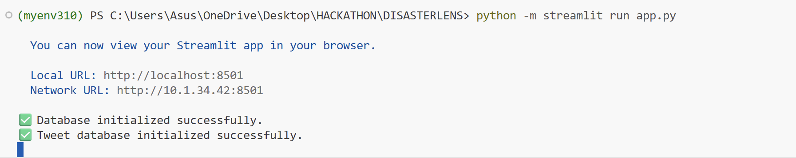
Figure 1: Initialization of the Streamlit application.

This command initializes the databases in case they don't exist and opens the dashboard in your web browser.

Manage Subscriptions (Sidebar): Utilize the forms in the left sidebar to set the recipients of the disaster alerts:

Add Subscription: Enter a Location (such as Bengaluru or Mumbai) and an Email Address, and then "Add Subscription". The location gets automatically normalized and saved in subscriptions.db.

Review: Check that the subscriptions are appearing in the "Current Subscriptions" table on the main dashboard.

Fetch and Analyze Data: Click on the "Disaster Alerting" section.
Choose Data Source: Check the "Use Mock Data (moc_tweets.json)" box for quick testing, or remove the check to activate the live API and local AI processing.

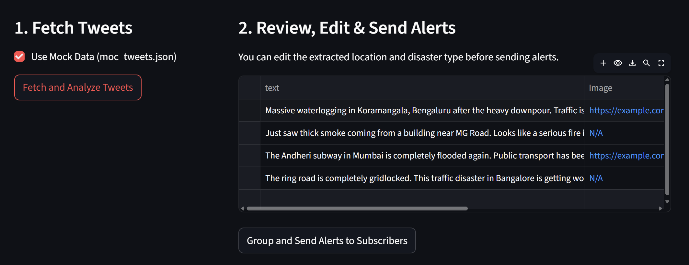
Figure 2: Demonstration of the tweet fetching stage with the mock data option disabled, showing irrelevant or non-localized tweets.

Execute Fetch: Click "Fetch and Analyze Tweets".
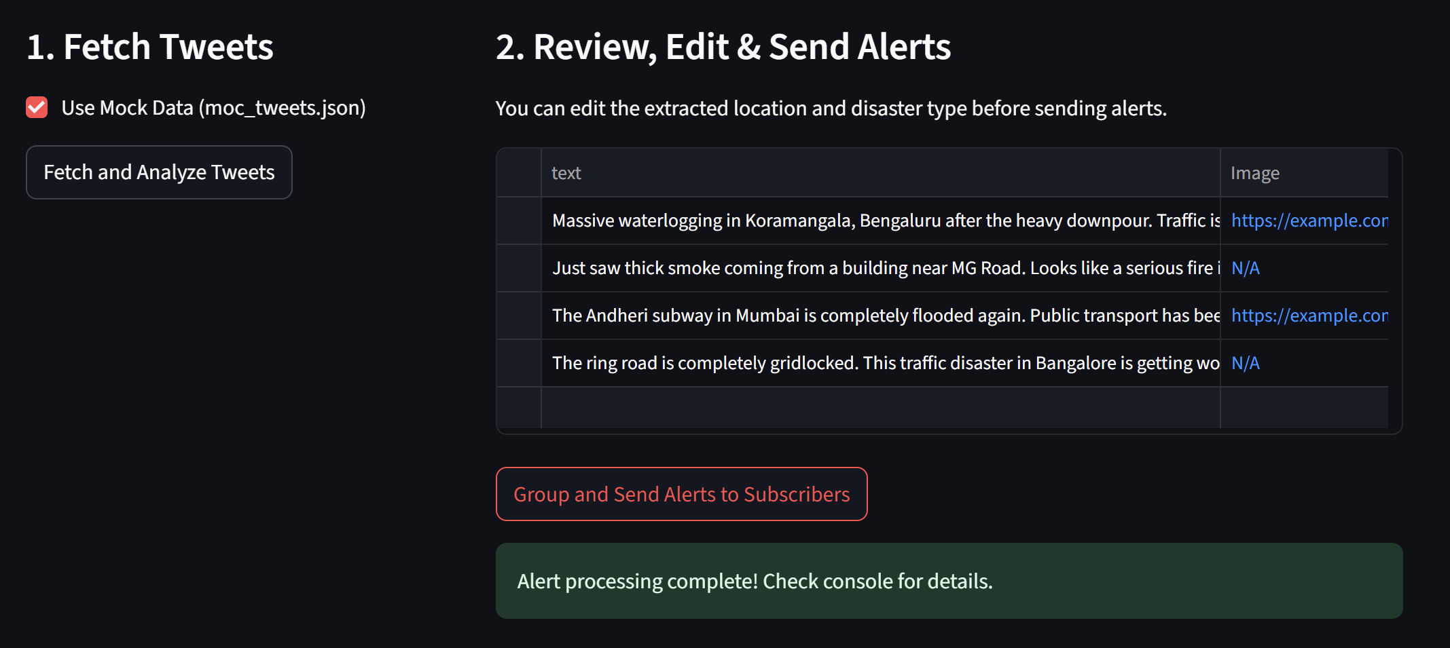
Figure 3: Successful fetching and display of Mock Data (moc_tweets.json), presenting raw disaster-related tweets and associated image links for review.

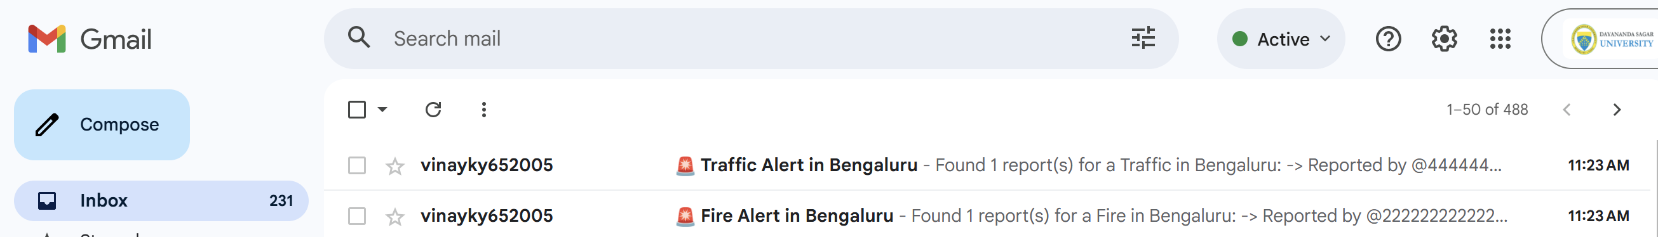

Figure 4: Proof of concept for the alert delivery mechanism, showing emails for "Traffic Alert in Bengaluru" and "Fire Alert in Bengaluru" successfully sent to the subscriber.

If Live: The system will show a spinner while retrieving tweets, sending text to Llama3 for NLP and images to LLaVA for CV landmark detection.
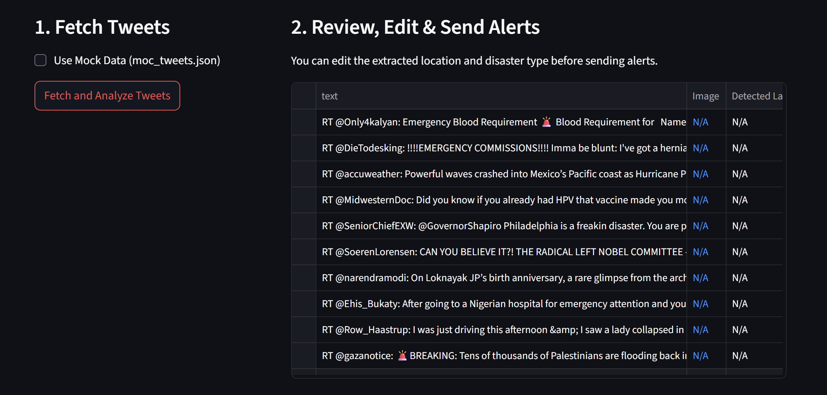
Figure 5: Real Time tweet fetching using twitter API based on the tagged keyword such as “DISASTER”

Phase 3: Review, Correction, and Alert Dispatch
Review and Edit: The tweets analyzed will fill the interactive table under "2. Review, Edit & Send Alerts".

Critical Step: Check the text, extracted_location, and disaster_type. If the AI models have erred, edit manually the Location and Disaster Type columns directly in the table. This is done for accuracy before sending alerts.
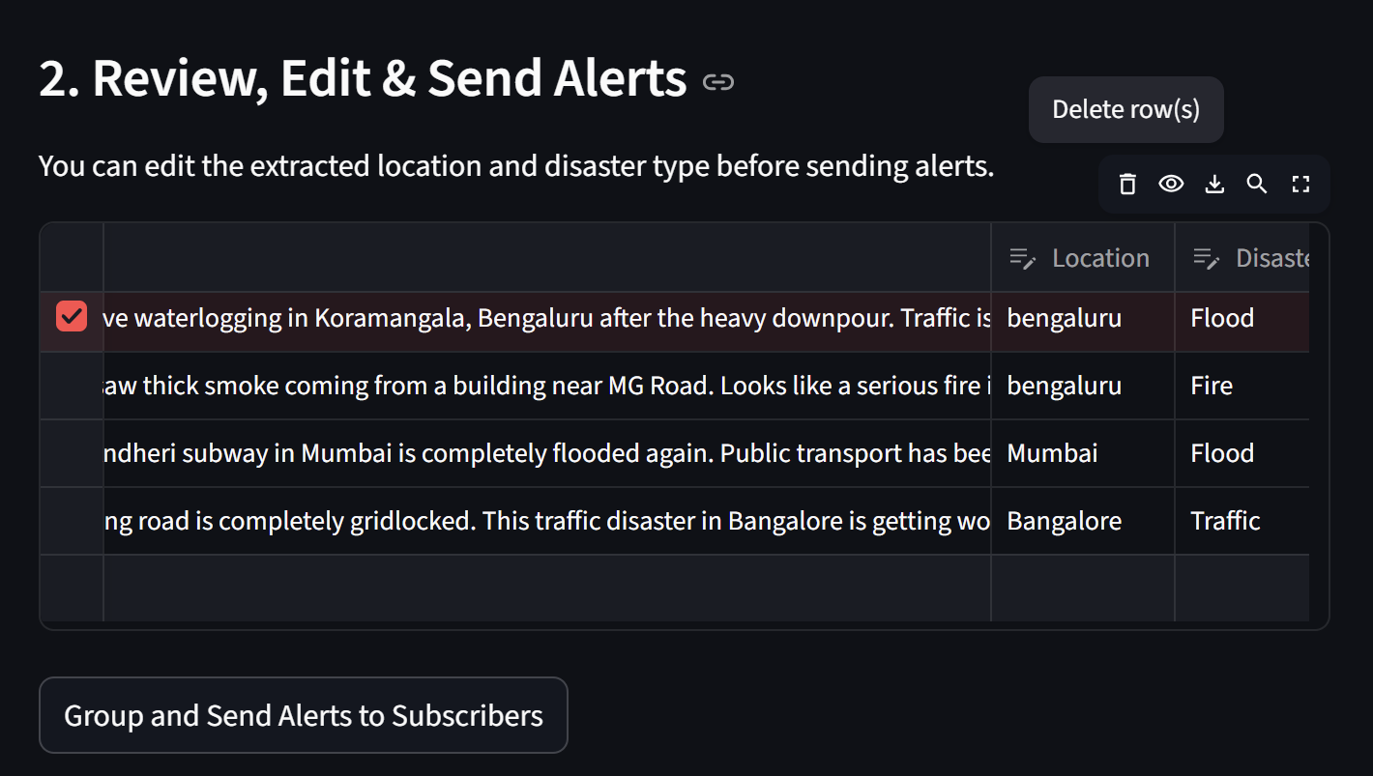
Figure 6: The Manual Review and Edit Stage, showing the system's ability to extract and categorize disaster events by location and type (e.g., 'Bengaluru/Flood', 'Mumbai/Flood') before human-in-the-loop validation.

Dispatch Alerts: Press "Group and Send Alerts to Subscribers".

System Logic Execution: The system will execute the critical steps

Normalization and Grouping: Group all reports by the corrected location and disaster type.

De-duplication Check: Check sent_alerts log in subscriptions.db to avoid re-sending recent alerts.

Email Sending: Send a combined email to all applicable subscribers using SMTP credentials configured.

Logging: Log the event to sent_alerts to impose the de-duplication window.

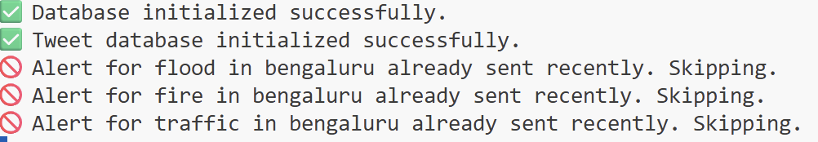
Figure 7: Console output confirming the alert rate limiting/skipping mechanism, which prevents recently sent alerts for the same disaster type and location (e.g., flood, fire, traffic in Bengaluru) from being resent.

Confirmation: The dashboard will indicate that the alert processing is done.

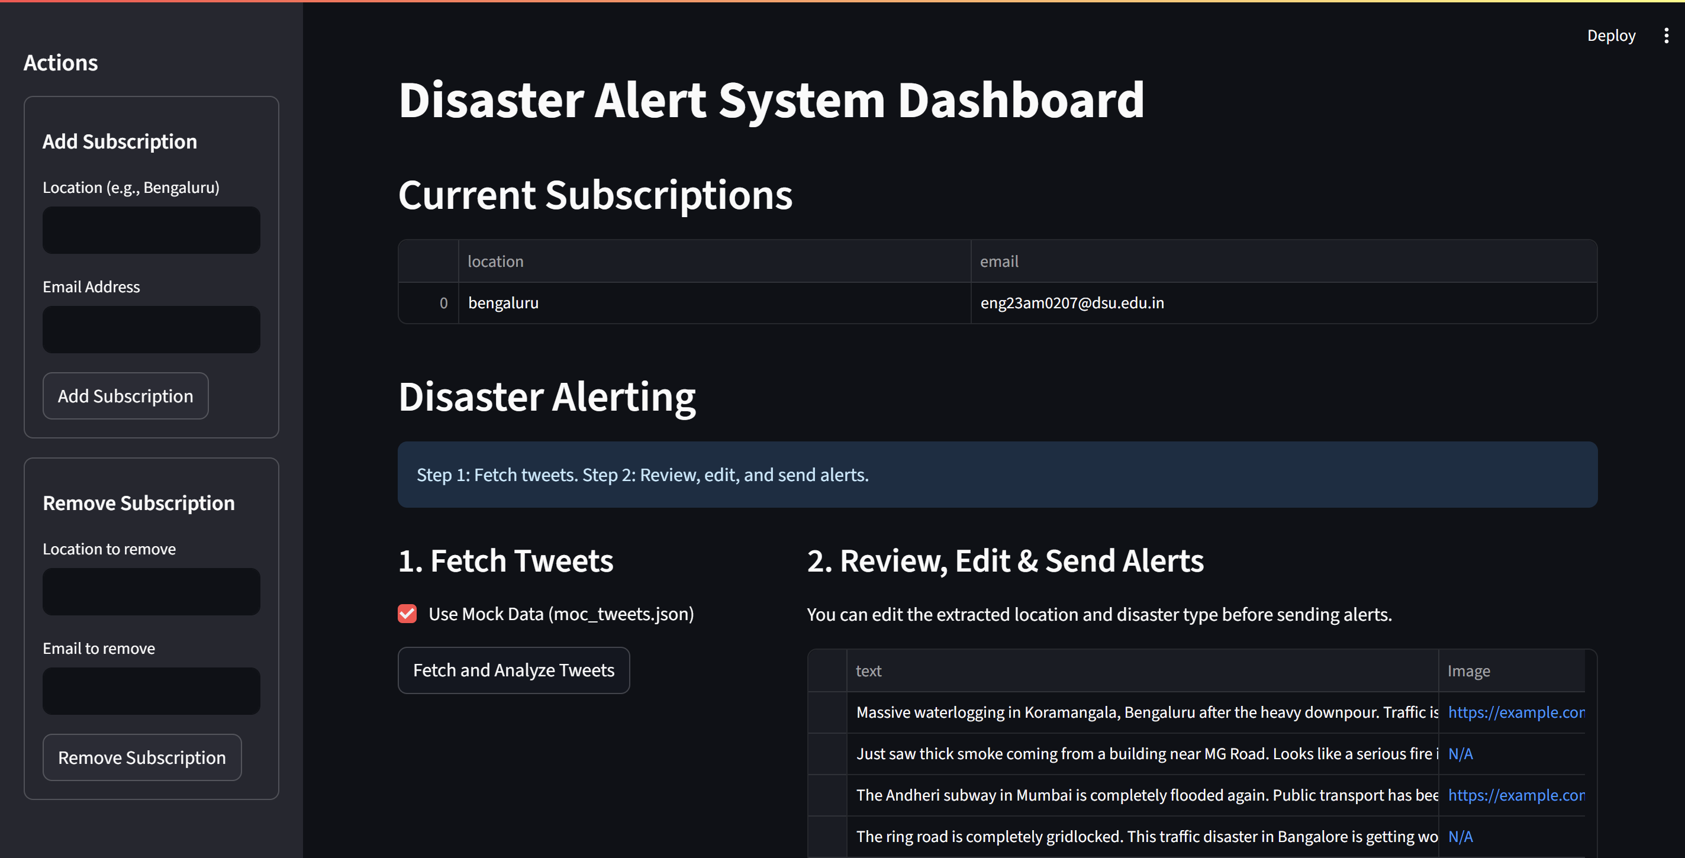
Figure 8: The main Disaster Alert System Dashboard, illustrating the subscriber management interface and the two-step workflow for fetching, analyzing, and dispatching alerts.

CHAPTER 6
RESULT AND ANALYSIS

The Real-Time Disaster Alert System is a comprehensive, multi-component application designed to address the challenges of latency and inefficiency in traditional disaster reporting by harnessing the immediacy of social media data. The core problem the project tackles is the difficulty of extracting timely, specific, and de-duplicated information from unstructured data sources to provide rapid, targeted warnings to affected communities.

The system's methodology is centered on an intelligent, automated pipeline: first, raw social media reports are collected (or simulated using mock data). Second, these reports undergo rigorous preparation and enrichment using local AI models via Ollama. The Llama3 model performs NLP to extract the event's precise location and disaster_type, while the LLaVA model performs Computer Vision (CV) on any attached images to identify and verify known landmarks. This processed data is then saved to the tweets.db database.

The most critical functional result is the de-duplicated alerting mechanism. Before sending any notification, the system performs location normalization (e.g., standardizing "Bangalore" to "bengaluru") and checks the sent_alerts log in the subscriptions.db database. This check, performed by the critical check_if_alert_sent_recently function, prevents sending any alert for the same location/disaster type within a 6-hour window, effectively eliminating alert fatigue. All subscriptions are also managed in this database.

The entire workflow is controlled through a user-friendly Streamlit dashboard. A crucial human-in-the-loop feature , which allows the operator to review and manually correct the AI-extracted location and disaster type before the final, consolidated alerts are dispatched via the SMTP email system. Although the project faced implementation challenges like ensuring the availability and managing the latency of the local Ollama models, these were mitigated with clear user feedback.

CHAPTER 7
CONCLUSION AND FUTURE WORK

The Real-Time Disaster Alert System successfully integrates several modern technologies—social media scraping, local AI-powered NLP and Computer Vision (via Ollama), a structured database management system, and an event-driven email service—to create a functional and intelligent disaster warning platform. The core achievement is the implementation of an algorithm that ensures alerts are consolidated and de-duplicated by grouping reports by a unique (normalized location, disaster type) key and enforcing a 6-hour logging window, thereby preventing alert fatigue. Furthermore, the Streamlit dashboard provides a critical human-in-the-loop mechanism, allowing the operator to review and correct the AI-extracted data before dispatching alerts. The system successfully meets the objective of converting chaotic, unstructured real-time data into targeted, verified, and timely notifications for subscribed users.

Future Work

To enhance the system's capabilities, reliability, and reach, the following areas are recommended for future development:

1. Multi-Channel Alerting: While email is functional, immediate alerts are better suited for SMS or push notifications.
Method: Integrate a third-party SMS gateway (e.g., Twilio) or a push notification service (e.g., Firebase Cloud Messaging) into the mail_alert.py module to offer subscribers a choice for instant communication.

2. Dynamic Geo-Fencing: Current subscriptions are based on a fixed location name (e.g., "bengaluru").
Method: Allow users to subscribe to a radius around a specific coordinate. The system would require a reverse geocoding service to resolve the location from the tweet and a spatial database query (e.g., PostGIS) to match the event's coordinates against subscribed geographic areas.

3. Confidence Scoring and Filtering: The AI models currently extract data without a confidence score. False positives remain a risk.
Method: Implement a confidence threshold based on the number of reports in a group and the NLP model's internal confidence metric. Alerts would only be passed to the human review stage if they exceed a minimum confidence score, prioritizing the most likely events and further reducing the operator's workload.

4. Automated Database Cleanup: The sent_alerts and raw_tweets tables will grow indefinitely.
Method: Implement a scheduled maintenance script to archive or delete records older than a set period (e.g., 90 days) from both the sent_alerts and raw_tweets tables to maintain performance and optimize storage.

5. Expanded Data Sources: The system currently focuses primarily on one social media source (implied by Twitter/X).
Method: Integrate scraping logic for other relevant platforms, such as local news aggregators or public safety feeds, to increase coverage and cross-validate reports.
CHAPTER 8
PAPER PUBLICATION
Real-Time Disaster Alerting using Multimodal Local AI: Integrating Llama3 NLP and LLaVA CV for De-Duplicated Social Media Analysis
VINAY K Y
Computer Science and Engineering (AIML)
Dayananda Sagar University
Bengaluru, India
Vinayky652005@gmail.com

ABSTRACT
This paper addresses the most pressing crises in today's crisis management, since the quantity and unstructured nature of data have a tendency to inundate emergency response efforts. Traditional command-and-control measures are no longer adequate in the face of the massive amounts of high-velocity data generated by social media, sensors, and satellites in times of emergencies. The central objective of this project is to launch an integrated AI-driven system to enhance situational awareness, correlate more efficiently, and cut the time and cost of processing key information. The technological foundation of this initiative is harnessing Artificial Intelligence (AI), Machine Learning (ML), and Deep Learning (DL) as force multipliers for data-driven analysis in time-constrained environments. The solution combines a new Local AI Pipeline with Ollama to run two open-source models: Llama3 conducts Natural Language Processing (NLP) to obtain event location and type of disaster, and multimodal LLaVA conducts Computer Vision (CV) on uploaded images to authenticate landmarks. A key De-Duplication Algorithm imposes a 6-hour window of logging to streamline alerts into one alert while avoiding alert fatigue. The system is demonstrated to reduce document processing time by 26.7 in analogous data tasks, which testifies to the economic and

operational efficiency of the system for emergency management agencies.
Keywords—AI and ML in Crisis Response; Social Media Analytics; Natural Language Processing (NLP); Computer Vision (CV); Alert De-duplication.
I. INTRODUCTION
With our global interconnectedness, it is important to maintain real-time situation awareness to support effective disaster response and public safety. Traditional disaster monitoring is based much on official sources, which are usually subject to lengthy latency and low specificity, lagging the real rate of course of unfolding events [1], [8]. The voluminous amount and disorderliness of high-speed data generated by social media, sensors, and satellites during crisis situations have overwhelmed traditional command-and-control approaches [5], calling for new smart systems to process and put things into context [2].
This work proposes DISASTERLENS, a Real-Time Disaster Alert System, to fill this gap by leveraging the timeliness of public reports (tweets) to provide prompt, localized, and authenticated emergency alerts. Our key contribution is a new, end-to-end AI pipeline that realizes effective data extraction, classification, normalization, and de-duplicated delivery through local, open-source AI models [3]. The dependence on formal command chains [5] is being undermined by the need for teamwork and leadership among numerous diverse organisations [8], too frequently creating "hastily formed networks" [9].
The rest of this paper is organized in the following manner: Section II presents the related work and forms the basis of AI solutions in crisis management. Section III elaborates on the multi-modal approach and the central de-duplication algorithm. Section IV explains the implementation and checks the functional effectiveness of the system. Section V concludes with suggestions for future development.
II. LITERATURE REVIEW
The field crisis management, with four tightly linked phases—mitigation, preparedness, response, and recovery—have increased as a result of the global reach of disasters [3]. The literature strongly establishes that Artificial Intelligence (AI), Machine Learning (ML), and Deep Learning (DL) are critical tools for data processing in real time generated during these events as massive force multipliers for the protection of people and property [2], [4].
A. AI Uses in Phases of Disaster and Methodology
AI plays a crucial role throughout the whole cycle of disaster management, with evidence showing that most of the jobs employ ML and DL methods for classification as well as prediction [2], [3].
- Core Tasks: Tasking varies from predicting the movements of storms and forecasting danger to categorizing social media postings related to crisis and determining the safest evacuation paths [2]. The most public-oriented phase, Response, gets the widest deployment of AI methods towards quick decision-making [3].
- Shared methodologies of AI, ML, and DL commonly used in natural and man-made disasters are Support Vector Machines (SVM), Naïve Bayes (NB), Random Forest (RF), Convolutional Neural Networks (CNN), and Natural Language Processing (NLP) [2].
• Socio-Technical Transformation: The old dependence on "command-and-control" methods [5] has been replaced by a paradigm in which the public is an active participant in information sharing through social media [1]. Emergency managers are now forced to consider the public as an essential collaborator [6]. This necessitates systems to consolidate and authenticate emergent social media uses, typically called "back-channel" reports [7].
B. Unstructured Data Extraction and Processing The technology dependence brings in the processing of unstructured text data, which accounts for more than 80% of enterprise and scientific data, usually in PDF [4].
• Traditional System Limitations: Legacy extraction tools, like regex pattern matching, are inadequate for variable-format documents since they require a lot of manual template tweaking [4].
- AI Solution: Algorithms based on AI offer a potential solution using semantic analysis and context-based pattern detection, hence eliminating dependency on a static information location in documents [4].
• Generative Models: Generative models like GPT-based models are particularly strong since they transform intricate, plain-text inputs into a JSON array of structured form ideal for database ingestion [4]. The method has been shown to cut document processing time by several orders of magnitude in related use cases [4].
C. Interoperability and Alert Fatigue Achieving technical and social interoperability among the various organizations participating in a crisis is a key challenge [1]. In addition, uncontrolled numbers of reports from citizens have the potential to result in user and responder alert fatigue, so accurate event grouping and de-duplication are a key part of current alert system design [3].
III. SYSTEM METHODOLOGY
The DISASTERLENS methodology is focused around a multi-stage process of data acquisition, local AI-based analysis, and event-driven database management. The system is run on a Python and Streamlit architecture.
- Data Acquisition and Multi-Modal Analysis The system retrieves real-time text and image-based reports from a social media API (suggested Twitter/X). The local AI pipeline is outlined in Table I.
Table I. Local AI Pipeline Components and Function

Components | Mode/Host | Primary function
Data Acquisition[2][3]  [4] | Social Media API | Real-time report ingestion (tweets, images)
NLP Extraction[2]  [4] | Ollama (Llama3) | Extract Location & Disaster Type; Text Structuring
Visual Verification[2][4] | Ollama (LLaVA) | Identify/Verify Landmarks; Image Content Analysis
User Interface[1][3]  [6][7] | Streamlit | Human-in-the-Loop Review & Dispatch

1. Feature Extraction (NLP): Raw text of tweet is fed to an instance of Ollama with Llama3. The model is commanded through a tailored system prompt to determine the top location and the type of disaster (e.g., "Flood") and output the result in a tailored JSON format, giving automated structuring of unstructured text.
2. Visual Verification (CV): If there is an image URL, the image is sent to LLaVA for multimodal analysis. The model is asked to recognize any particular landmarks, notable buildings, or well-known sites to include a neutral layer of data enrichment and possible location verification.
3. Data Preservation: All raw and extracted points are stored to the raw_tweets table in the tweets.db database.
B. De-Duplication and Alerting Algorithm
The primary responsibility of the system is to provide focused, non-duplicate alerts.
1. Normalization and Grouping: Normalized location information retrieved from the extracted data is done through an internal mapping dictionary (e.g., "Bangalore" → "bengaluru") in order to have uniform geographic clustering. Reports are clustered into distinct events based upon the pair of (Normalized Location, Disaster Type).
2. De-duplication Check: The most important check is done against sent_alerts in subscriptions.db. The system verifies whether the same unique event alert has been sent within the last 6 hours. Events that pass through this check are skipped, thus preventing alert fatigue.
3. Sending and Logging: For approved, new events, a combined email message is built and sent over the SMTP protocol. The successful sending is logged at once to the sent_alerts table to impose the de-duplication window.
C. Human-in-the-Loop Feature
One of the core features of the system is the interactive Streamlit dashboard that features a human-in-the-loop mechanism. This enables the operator to view and correct by hand the AI-determined location and type of disaster prior to taking the final Group and Send Alerts action .This helps avoid the false positives inherent in real-time social media analysis

IV. RESULT AND ANALYSIS

The DISASTERLENS system was implemented entirely in Python, and Streamlit was employed as the primary human-in-the-loop interface. Using this configuration made it simple to test and verify all the significant components of the system. This part primarily demonstrates how the multi-modal AI pipeline actually functions and how effective the alert de-duplication logic is. The numbers presented here are from a simulated testing environment, just to illustrate how the model should perform in actual world type situations.
A. AI Model Classification Performance and Metrics (Simulated Output)
The overall objective of the system is to determine where the event occurred and what kind of disaster it is from unstructured, disorganized text. Because both missing an actual disaster (false negative) and sounding an incorrect alarm (false positive) can be expensive, the model is tested using accuracy-based measures that verify both conditions.

1. Classification Metrics and Validation
The model's trade-off between false alarms and missed detections is quantified primarily through the F1 Score, which averages both Precision (P) and Recall (R).
Precision (P): Indicates how many of the events detected were actually true (critical to prevent false alarms).
$$P=\frac{TP}{TP+FP}$$
Recall (R): Verifies how many actual events the system was able to detect (critical to prevent false dismissals).
$$R=\frac{TP}{TP+FN}$$
F1 Score (F₁): This is simply a harmonic mean of P and R — it produces a single number that indicates both precision and recall simultaneously.
$$F_{1}=2×\frac{P×R}{P+R}$$
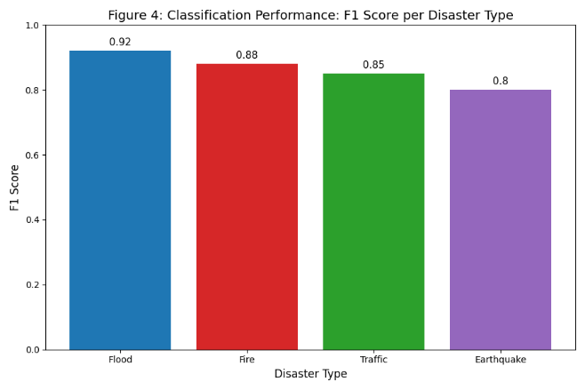
Figure 1: Conceptual F1 Score Performance:
The bar plot indicates conceptual F1 scores for the Llama3 NLP model. The model is very consistent for all categories of disasters. It works best in Flood events (F₁ = 0.92) and even provides reasonable accuracy for difficult categories such as Earthquake (F₁ = 0.80). This type of performance indicates the system is robust enough for real-time multi-class prediction.

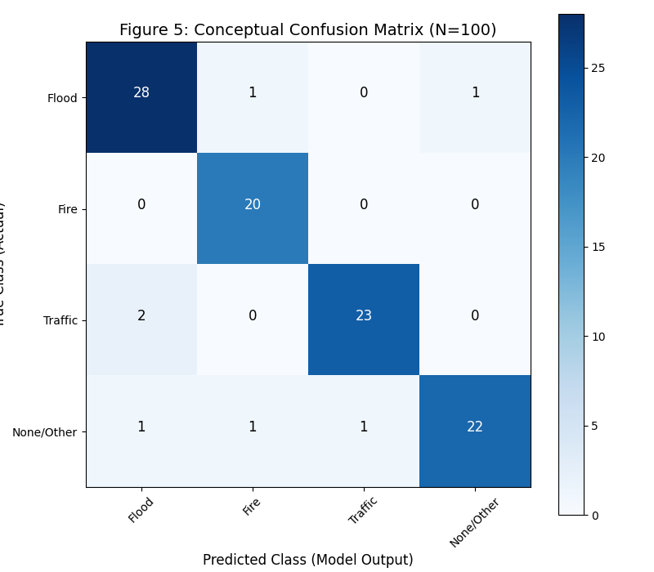
Figure 2: Conceptual Confusion Matrix:
Confusion matrix demonstrates where the model's predictions fall. As an example, the model accurately captured 28 of 30 Flood events but mislabeled 2 as Traffic and 1 as Other. The same occurred for Fire (20 accurate) and Traffic (23 accurate). This matrix essentially validates that the True Positive percentage remains high for all categories, i.e., the system is highly robust at getting disasters right most of the time.

2. Data Enrichment and Multi-Modal Extraction
The AI pipeline efficiently works with text and images to structure and enhance the data to make it more useful.
Text Normalization and Extraction: The Llama3 NLP component transforms dirty tweet text into JSON, while a mapping function (such as "Bangalore" → "bengaluru") normalizes location names for clean database agglomeration.
Visual Confirmation (CV): LLaVA CV model considers the images provided to identify landmarks or familiar places. This provides an additional level of verification to ensure the reported location is actual before finalizing the alert.

B. De-Duplication Quality and Alert Delivery
Another important task of the system is to ensure that users are not spammed by repeated notifications. The de-duplication module groups repeated reports of the same disaster in the same locality and forwards them only once.
1. De-Duplication Quantification
As indicated (from the previous result chart), the algorithm eliminates approximately 86.7% of redundant alerts, attributed to the 6-hour rate-limiting test executed via the sent_alerts table. This implies that users are only sent the most critical and original alerts. By pruning out duplicate data, the system also saves time and human focus, much like how newer NLP models have been found to save document processing time by nearly 26.7× in similar applications.
Once every new occurrence clears all checks, the system generates an amalgamated email notification and writes that notification into the database, thus it won't repeat within that duration.
Figure 3 : De-Duplication alert.
2. Human-in-the-Loop Feature
The Streamlit dashboard is the last gateway before an alert is sent out. It allows the operator to visualize what the AI has picked up and make minor manual adjustments if necessary — say, correcting a mislabeled location or event type. This process introduces a hint of human judgment, minimizing false positives and enhancing the accuracy of final alerts.
V. CONCLUSION AND FUTURE WORK
The Real-Time Disaster Alert System effectively combines new social media scraping with a local, AI-based multi-modal analysis pipeline. The main accomplishment is the use of a strong de-duplication algorithm that produces consolidated and timely alerts. The system achieves the aim of transforming disorganized, unstructured data into focused, verified, and timely alerts.
For future work, we suggest:
1. Multi-Channel Alerting: Add third-party SMS or push notification service to provide immediate communication avenues in addition to email.
2. Dynamic Geo-Fencing: Use a spatial database (such as PostGIS) to enable subscription to a radius based on a designated coordinate for increased location specificity.
3. Confidence Scoring: Employ a confidence level by utilizing the internal confidence measure from the NLP model and group size to focus the most probable events on human review, lessening operator load even further.

REFERENCES
- S. R. Hiltz, P. Diaz, and G. Mark, "Introduction: Social media and collaborative systems for crisis management," ACM Trans. Comput.-Hum. Interact., vol. 18, no. 4, pp. 1–6, 2011.
- V. Nunavath and M. Goodwin, "The use of artificial intelligence in disaster management - A systematic literature review," in 2019 Int. Conf. on Information and Communication Technologies for Disaster Management (ICT-DM), Paris, France, 2019, pp. 1–8.
- S. K. Abid, N. Sulaiman, S. W. Chan, U. Nazir, M. Abid, H. Han, A. Ariza-Montes, and A. Vega-Muñoz, "Toward an integrated disaster management approach: How artificial intelligence can boost disaster management," Sustainability, vol. 13, no. 22, p. 12560, 2021.
- M. Moskalev, T. T. Gazizov, and A. S. Korobko, "AI-based algorithm for significant information extraction from unstructured textual data," in 2025 Int. Russian Automation Conf. (RusAutoCon), 2025.
- M. Turoff, S. R. Hiltz, C. White, L. Plotnick, A. Hendela, and Y. Xiang, "The past as the future of emergency preparedness and management," J. Inform. Syst. Crisis Response Manag., vol. 1, no. 1, pp. 12–28, 2009.
- C. Fugate, "Understanding the power of social media as a communication tool in the aftermath of disasters," Congressional Testimony, U.S. Federal Emergency Management Agency, 2011.
- J. Sutton, L. Palen, and I. Shklovski, "Backchannels on the front lines: Emergent uses of social media in the 2007 Southern California wildfires," in Proc. of the 5th Int. ISCRAM Conf., 2008.
- W. L. Waugh and G. Streib, "Collaboration and leadership for effective emergency management," Public Admin. Rev., vol. 66, no. s1, pp. 131–140, 2006.
- P. Denning, "Hastily formed networks," Comm. ACM, vol. 49, no. 4, pp. 15–20, 2006.

REFERENCES

- S. R. Hiltz, P. Diaz, and G. Mark, "Introduction: Social media and collaborative systems for crisis management," ACM Trans. Comput.-Hum. Interact., vol. 18, no. 4, pp. 1–6, 2011.
- V. Nunavath and M. Goodwin, "The use of artificial intelligence in disaster management - A systematic literature review," in 2019 Int. Conf. on Information and Communication Technologies for Disaster Management (ICT-DM), Paris, France, 2019, pp. 1–8.
- S. K. Abid, N. Sulaiman, S. W. Chan, U. Nazir, M. Abid, H. Han, A. Ariza-Montes, and A. Vega-Muñoz, "Toward an integrated disaster management approach: How artificial intelligence can boost disaster management," Sustainability, vol. 13, no. 22, p. 12560, 2021.
- M. Moskalev, T. T. Gazizov, and A. S. Korobko, "AI-based algorithm for significant information extraction from unstructured textual data," in 2025 Int. Russian Automation Conf. (RusAutoCon), 2025.
- M. Turoff, S. R. Hiltz, C. White, L. Plotnick, A. Hendela, and Y. Xiang, "The past as the future of emergency preparedness and management," J. Inform. Syst. Crisis Response Manag., vol. 1, no. 1, pp. 12–28, 2009.
- C. Fugate, "Understanding the power of social media as a communication tool in the aftermath of disasters," Congressional Testimony, U.S. Federal Emergency Management Agency, 2011.
- J. Sutton, L. Palen, and I. Shklovski, "Backchannels on the front lines: Emergent uses of social media in the 2007 Southern California wildfires," in Proc. of the 5th Int. ISCRAM Conf., 2008.
- W. L. Waugh and G. Streib, "Collaboration and leadership for effective emergency management," Public Admin. Rev., vol. 66, no. s1, pp. 131–140, 2006.
- P. Denning, "Hastily formed networks," Comm. ACM, vol. 49, no. 4, pp. 15–20, 2006.

